RESOURCES AND INFORMATION – What is OER? BootCamp 2022
Directories:
- UofR OER by Subject Directory: https://opentextbooks.uregina.ca/ureginaoerdirectory/
- PressBooks Directory: https://pressbooks.directory/

Library Guides:
- Open Access: https://uregina.libguides.com/openaccess
- Open Educational Resources: https://uregina.libguides.com/oer
- Open Textbooks: https://uregina.libguides.com/opentextbooks

Platforms and Repositories (UofR OER by Subject Directory for more):
- PressBooks: https://pressbooks.com/
- LibreTexts: https://libretexts.org/
- OER Commons: https://www.oercommons.org/
Other OER Tools:
- H5P: https://h5p.org
- eCampusOntario H5P Studio: https://h5pstudio.ecampusontario.ca/
Contact Information:
- Isaac Mulolani: isaac.mulonani@uregina.ca , https://opentextbooks.uregina.ca/
- Arlysse Quiring: arlysse.quiring@uregina.ca , www.uregina.ca/libary
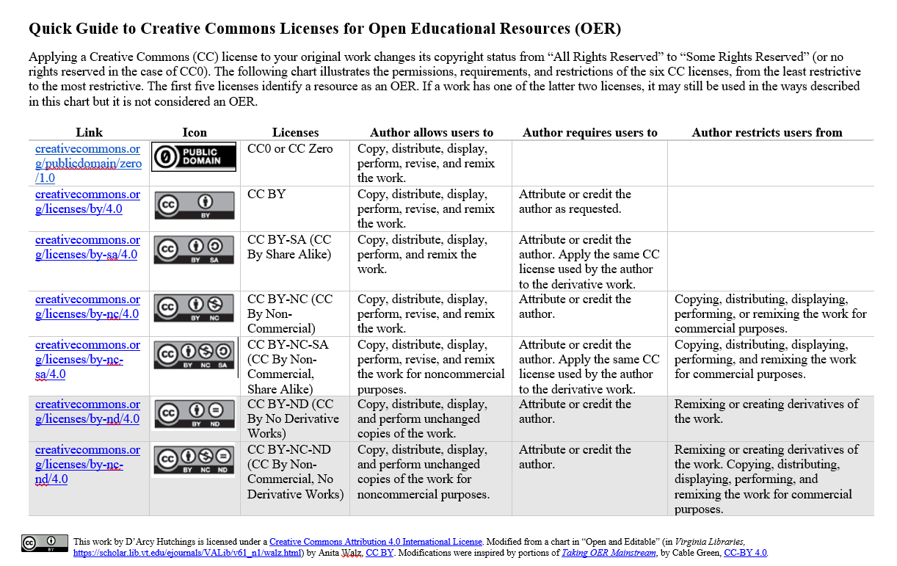
Tool | Type of tool | Source
Office 365 | Commercial | https://www.office.com/
Google Documents | free | https://workspace.google.com/
LibreOffice | Open-source | https://www.libreoffice.org/
WPS Office | Freeware | https://wps.com/
Softmaker Office | Commercial | https://www.softmaker.com/en/
Pressbooks | Open-source, paid | https://pressbooks.com/
Libretexts | Free | https://libretexts.org/
EdTech Books | Free | https://edtechbooks.org/
RMarkdown | Open-source | https://rmarkdown.rstudio.com/
LaTeX | Open-source | https://www.latex-project.org/
TeXLive | Open-source | https://tug.org/texlive/
MacTeX | Open-source | https://tug.org/mactex/
Gnu TeXmacs | Open-source | https://www.texmacs.org/
LyX | Open-source | https://www.lyx.org/
Overleaf | Commercial | https://www.overleaf.com/
PreTeXt | Open-source | https://pretextbook.org/
WordPress | Commercial | https://wordpress.com/
OER Commons | Free | https://www.oercommons.org/
Manifold | Open-source | https://manifoldapp.org/
Fulcrum | Open-source | https://www.fulcrum.org/
MERLOT | Free | https://merlot.org/merlot/login.htm
GitBook | Freeware | https://www.gitbook.com/
Bookdown | Open-source | https://bookdown.org/yihui/bookdown/
GIMP | Open-source | https://www.gimp.org/
Inkscape | Open-source | https://inkscape.org/
Wikibooks | Free | https://en.wikibooks.org/
TED-Ed Content Builder Tool | Free | https://ed.ted.com/
H2O | Free | https://h2o.law.harvard.edu/

